**Họ và tên: Đoàn Vũ Phú Minh**

**MSSV: 22520859**

1.

a)

.data

array1: .word 5, 6, 7, 8, 1, 2, 3, 9, 10, 4 #khai bao mang array1

size1: .word 8 # khai bao phan tu mang array 1

array2: .byte 1, 2, 3, 4, 5, 6, 7, 8, 9, 10, 11, 12, 13, 14, 15, 16

size2: .word 16

ar1: .asciiz "Phan tu mang arr1 la: "

ar2: .asciiz "\nPhan tu mang arr2 la: "

space: .asciiz " "

.text

arr1:

la $a0, ar1 #$a0 = ar1

li $v0, 4 # $v0 =4

syscall

la $s0, array1 #$s0 la dia chi nen cua mang array1

addi $t2, $t2, 0 # t2=0

addi $t3, $t3, 10 # t3=10

loop:

beq $t2, $t3, arr2 # $t2 =$t3 nhay den arr2

la $v0, 1 # $v0 =1

lw $t1, 0($s0) # lay gtri trong $s0 vao $t1

add $a0, $t1, $0 # $a0 =$t1

syscall # in ra cac phan tu tai $s0

la $a0, space # in ra khoang trong

li $v0, 4

syscall

addi $s0, $s0, 4 # $s0 = $s0 +4 ( work ke tiep)

addi $t2, $t2, 1 #$t2 = $t2 +1

j loop # nhay toi loop

arr2:

la $a0, ar2

li $v0, 4

syscall # in ra ar2

la $s1, array2 # gan $s1 = gtri nen cua array2

addi $t2, $t2, 0 # $t2=0

addi $t3, $t3, 16 # $t3=16

loop2:

beq $t2, $t3, Exit # neu $t2= $t3 thi nhay toi Exit

la $v0, 1 #$v0=1

lb $t1, 0($s1) # doc gtri $t1 vao $t1

add $a0, $t1, $0 # $a0=$t1

syscall # in ra phan tu tai $s1

la $a0, space

li $v0, 4

syscall # in ra khoang trong

addi $s1, $s1, 1 # 4s1 = $s1+1 ( chuyen toi byte ke tiep)

addi $t2, $t2, 1 #$t2=$t2+1

j loop2

Exit:

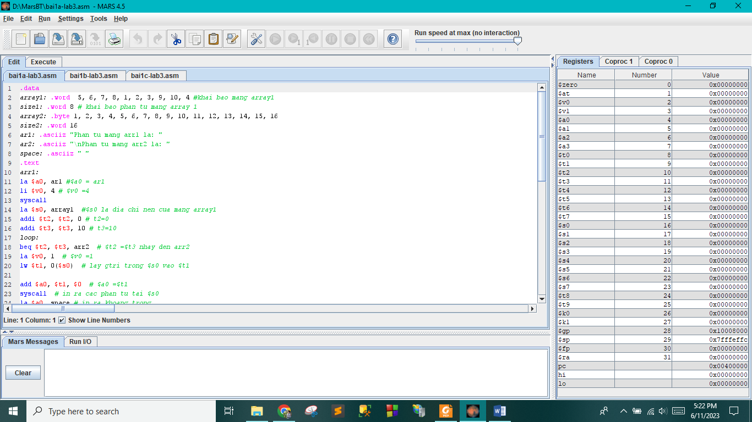

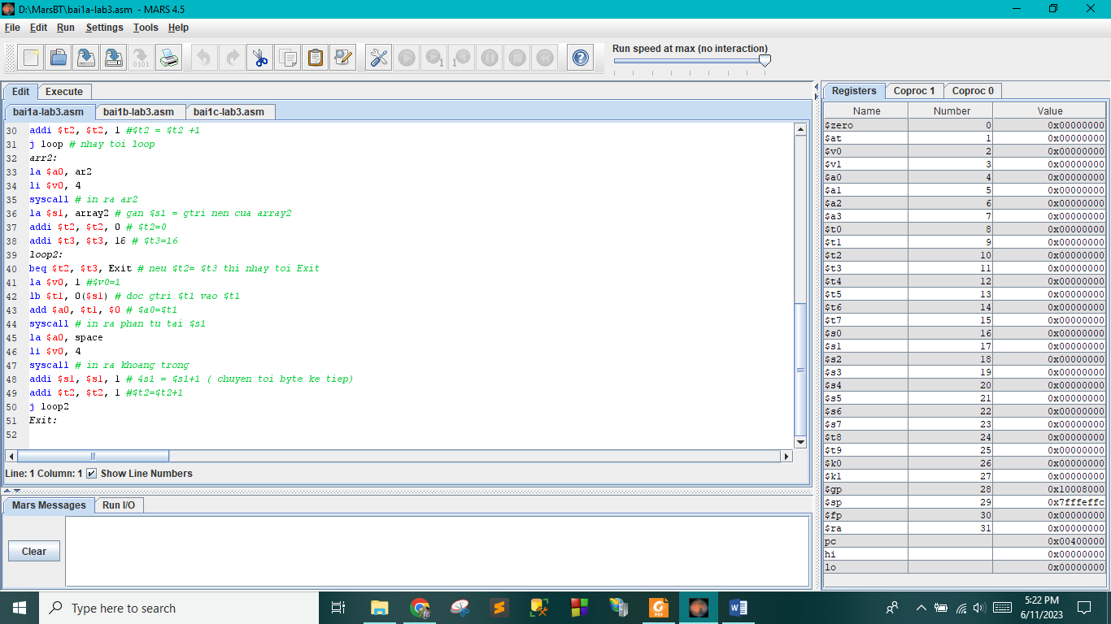

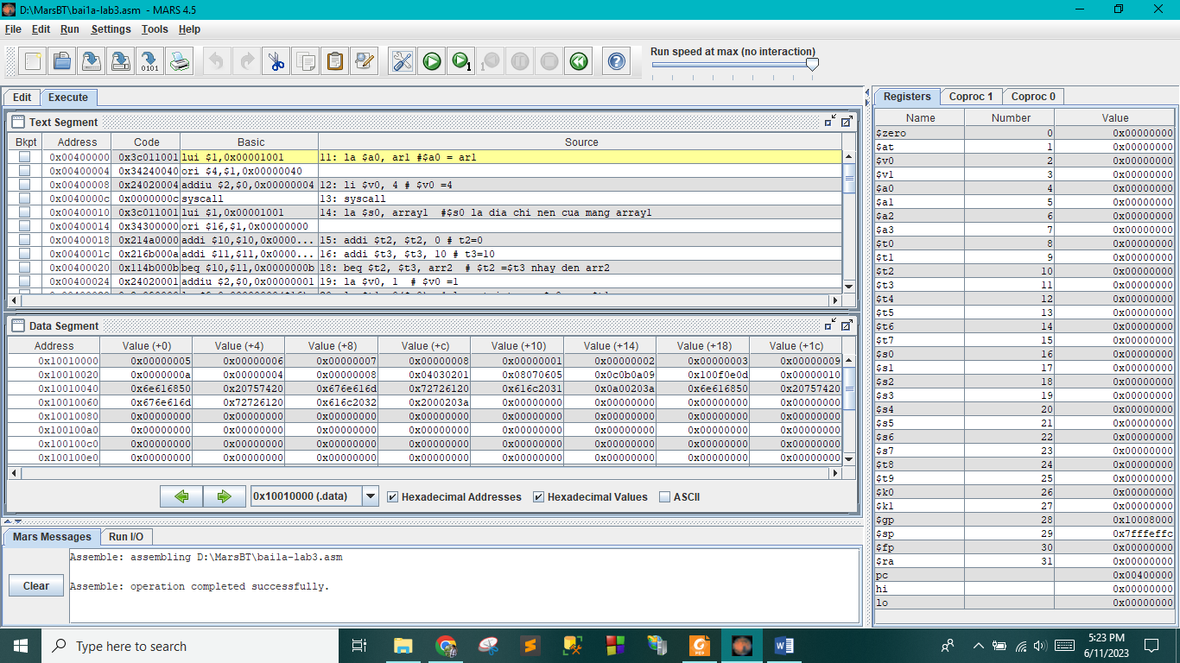

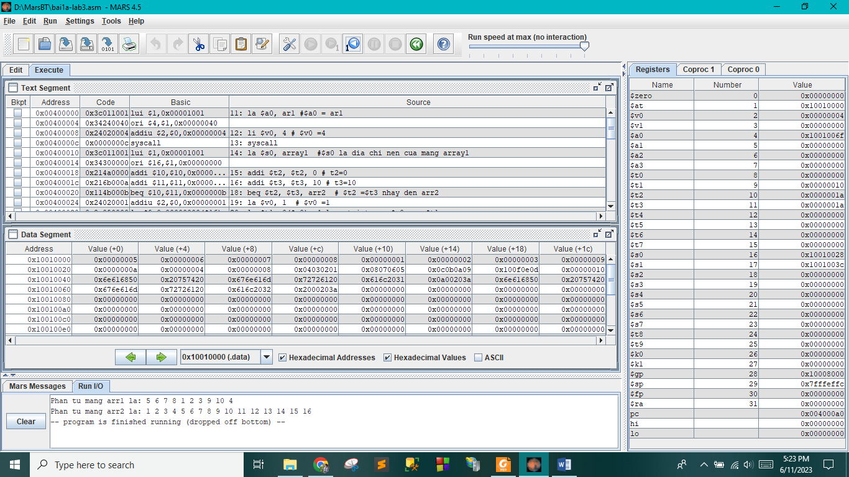

b)

.data

array1: .word 5, 6, 7, 8, 1, 2, 3, 9, 10, 4 #khai b�o ph?n t? m?ng array1

size1: .word 10 #khai b�o k�ch th?c m?ng array1

array2: .byte 1, 2, 3, 4, 5, 6, 7, 8, 9, 10, 11, 12, 13, 14, 15, 16

size2: .word 16

array3: .space 8

size3: .word 8

ar3: .asciiz "\nPhan tu mang array3 la: " #khai b�o chu?i ar3

space: .asciiz " " #khai b�o k� t? kho?ng tr?ng

.text

la $s0, array3 #l?u gia tri nen mang array3 vao thanh ghi $s0

la $s1, array2 #luu gtri nen mang array2 vao thanh ghi $s1

li $t0, 8

li $t1, 0

la $a0, ar3

li $v0, 4 # in ra chuoi ar3

syscall

main:

slt $t3, $t1, $t0 # if $t1 < $t0 , $t3 =1

beq $t3, 0, Exit # $t3 =0 ,nhay toi Exit

add $t4, $s1, $t1 # $t4= $t1+$t1

lb $t5, 0($t4) # doc gtri $t4 vao $t5

li $t6, 16 #$t6 = 16

addi $a0, $t6, -1 # $a0 = $t6-1 (size 2-1)

sub $a1, $a0, $t1 # $a1 = $a0 -$t1 ( size 2-1-i)

add $t7, $s1, $a1 # cong them dia chi nen cua mang arrray2

lb $t8, 0($t7) # doc gtri $t7 vao $t8

add $a2, $s0, $s3 #$a2= $s0 + $s3

lb $s5, 0($a2) # doc gtri $a2 vao $s5

add $s4, $t5, $t8 # $s4 =$t5+ $t8

addi $s5, $s4, 0 # $s5 =$s4

addi $a0, $s5, 0 # $a0 =$s5

li $v0, 1

syscall # in ra $s5

la $a0, space # in ra khoang trong

li $v0, 4

syscall

sll $s3, $s3, 2 #$s3*=4

addi $t1, $t1, 1 #$t1+=1

j main

Exit:

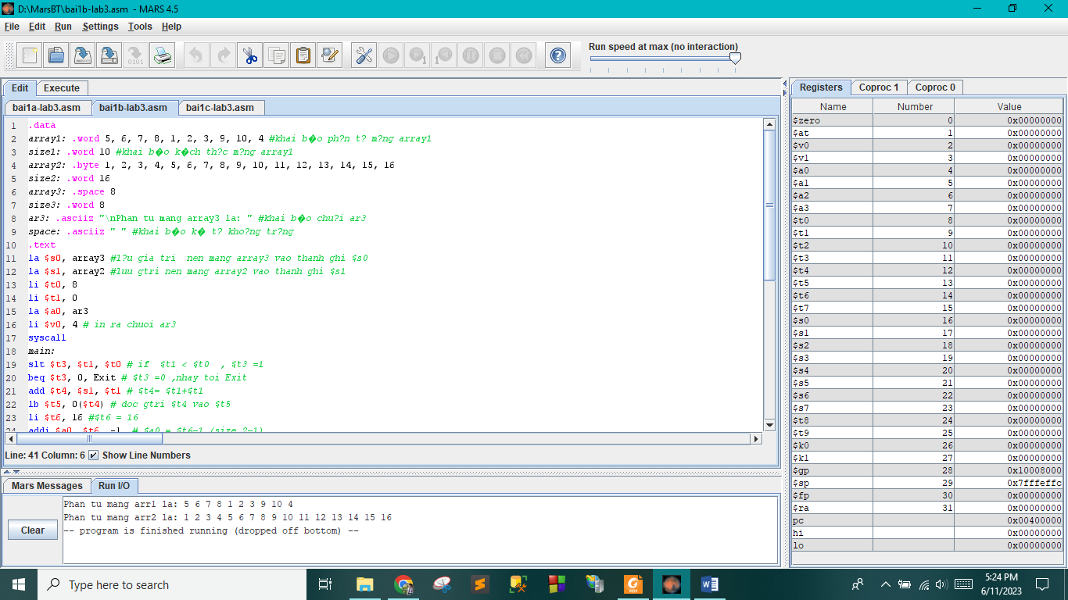

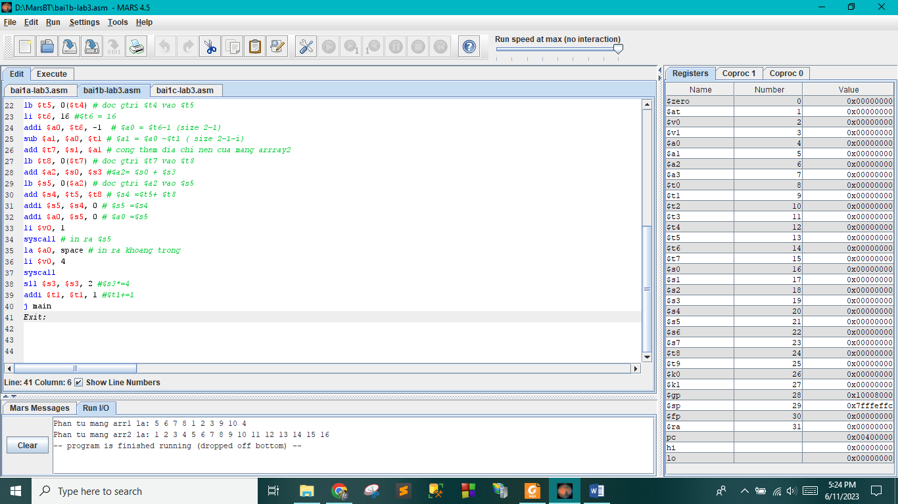

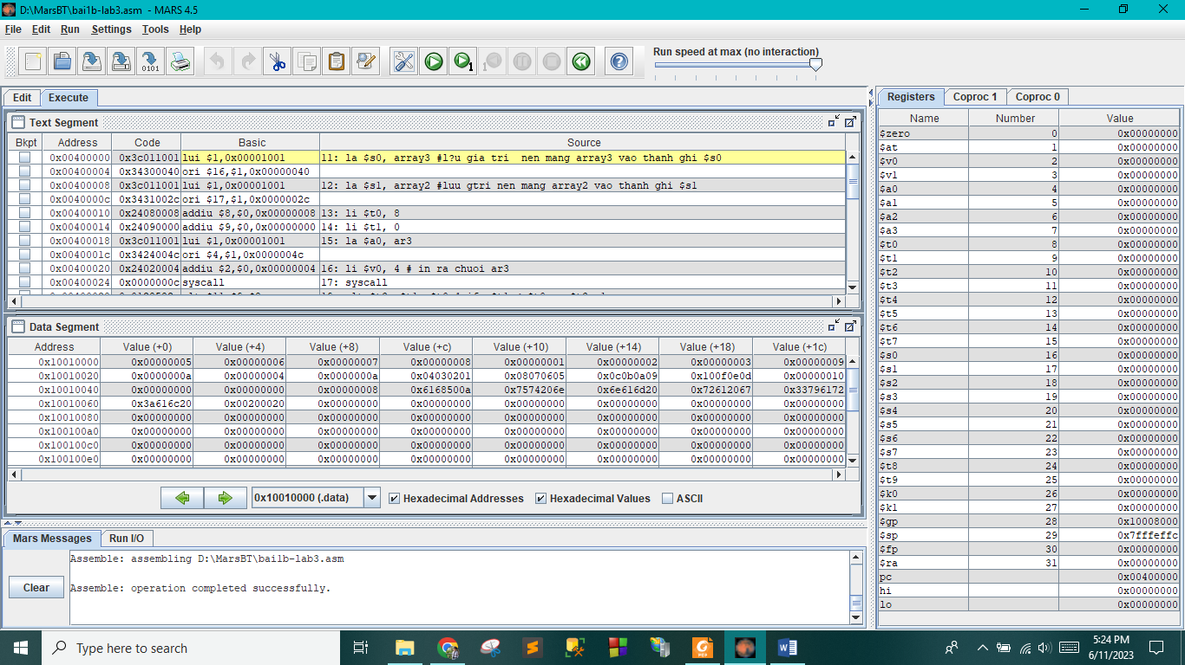

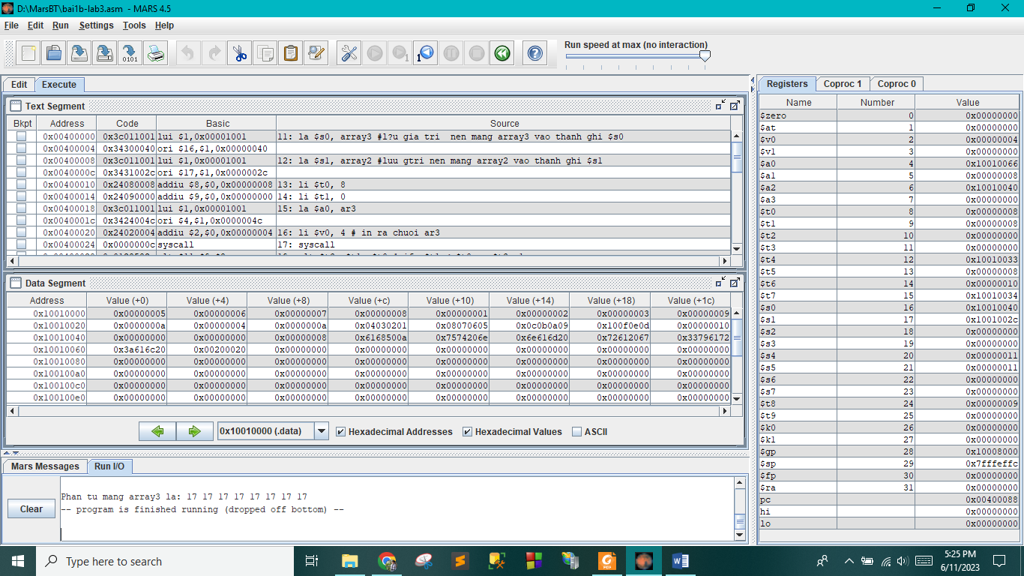

c)

.data

array1: .word 5, 6, 7, 8, 1, 2, 3, 9, 10, 4

size1: .word 10

array2: .byte 1, 2, 3, 4, 5, 6, 7, 8, 9, 10, 11, 12, 13, 14, 15, 16

size2: .word 16

str1: .asciiz "Dia chi mang: "

str2: .asciiz "\nDia chi phan tu: "

str3: .asciiz "\nPhan tu la: "

space: .asciiz " "

.text

la $s1, array1 # luu gia tri nen mang array1

la $s2, array2 # luu gtri nen mang array2

la $a0, str1

li $v0, 4

syscall # in ra chuoi str1

li $v0, 5

syscall

addi $t1, $v0, 0 # $t1=$v0

beq $t1, 1, arr1 # if $t1=1, nhay toi arr1

beq $t1, 2, arr2 # if $t1 =2 , nhay toi arr2

arr1:

li $s5,0 #$s5 =0

la $a0, str2

li $v0, 4

syscall # in ra chuoi str2

li $v0, 5 # nhap gtri $vo

syscall

addi $t0, $v0, 0

loop1: #$t0 = $v0

beq $s5, $t0, out1 # if $s5=$t0 , nhay toi out1

addi $s5, $s5, 1 # $s5 = $s5 +1

sll $s6, $s5, 2 # $s6 = $s5 *4

j loop1

out1:

add $s7, $s1, $s6 # $s7 = $s1 +$s6

lw $t0, 0($s7) # doc gtri $s7 vao $t0

la $a0, str3

li $v0, 4

syscall # xuat ra chuoi str3

add $a0, $t0, 0 # $a0 =%t0

li $v0, 1 # in ra $a0

syscall

j Exit

arr2:

la $a0, str2

li $v0, 4

syscall # in ra str2

li $v0, 5

syscall # nhap $v0

addi $t2, $v0, 0 #$t2 = $v0

loop2:

beq $t3, $t2, out2 # if $t3 = $t2, nhay toi out2

addi $t3, $t3, 1 # $t3 = $t3+1

j loop2 # nhay toi loop2

out2:

add $t5, $s2, $t3 # $t5 =$t2+$t3

lb $t4, 0($t5) # doc thanh ghi $t5 vao $t4

la $a0, str3

li $v0, 4

syscall # in ra chuoi str3

add $a0, $t4, 0

li $v0, 1

syscall # in ra $a0

j Exit

Exit:

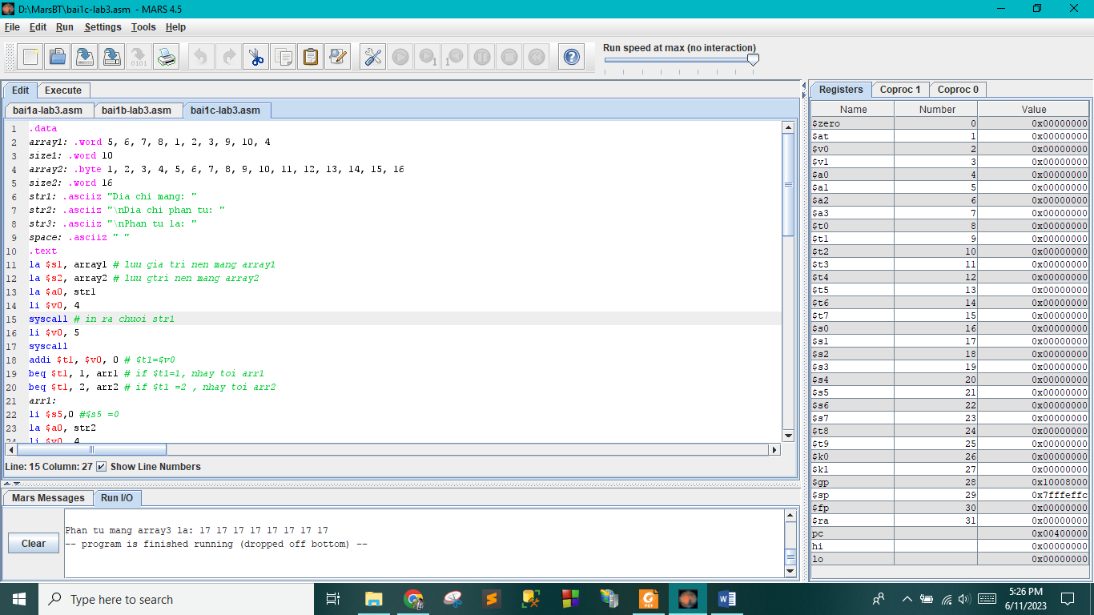

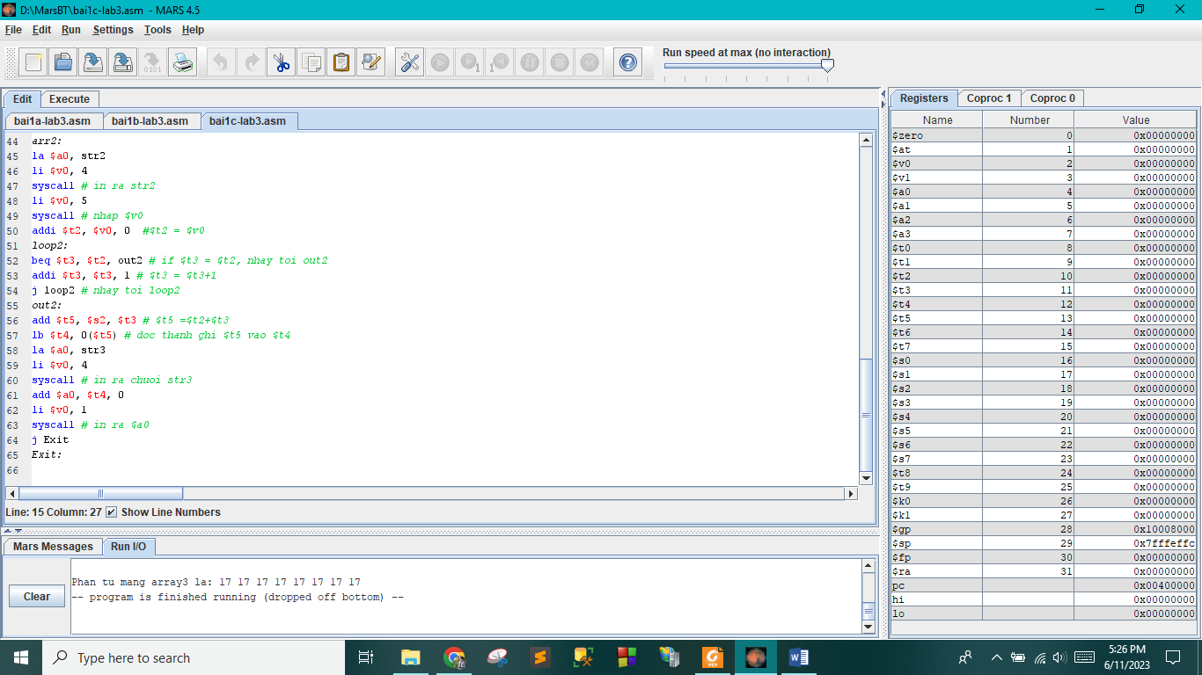

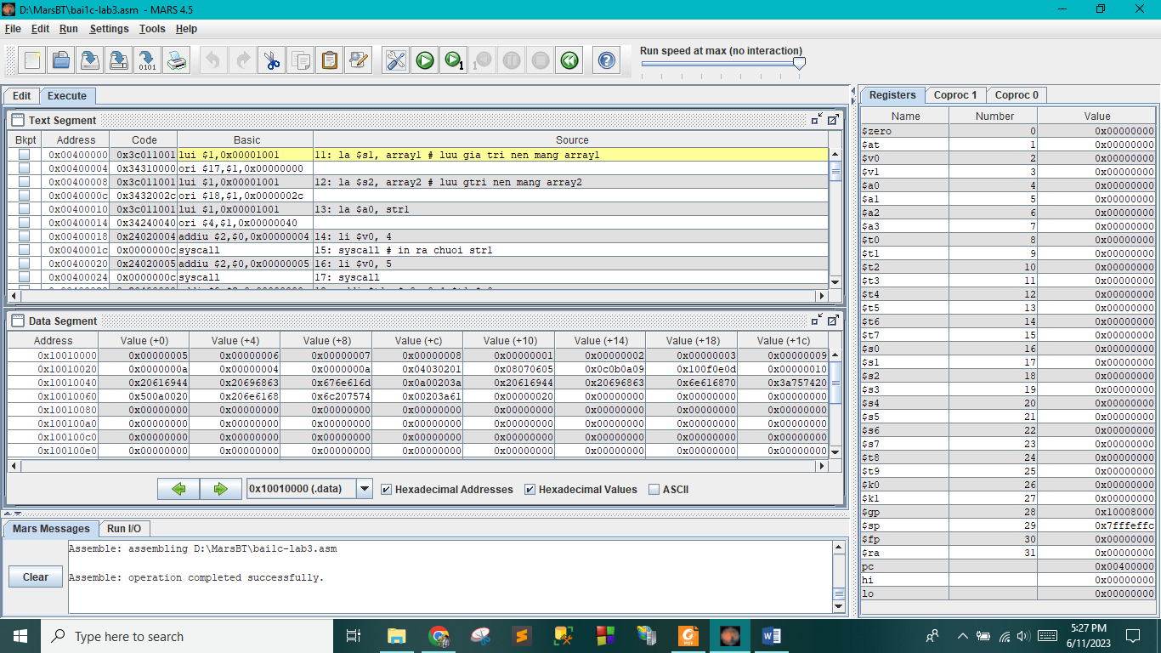

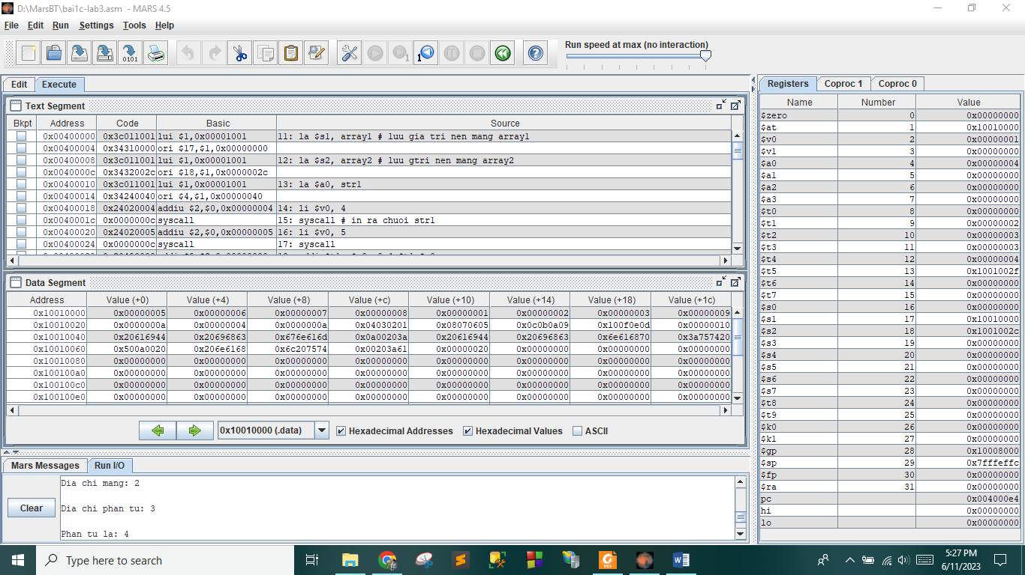

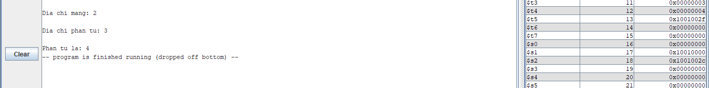

2.

.data

array1: .word 5,6,7,8,1,2,3,9,10,4

size1:.word 10

array2:.byte 1,2,3,4,5,6,7,8,9,10,11,12,13,14,15,16

size2: .word 16

array3:.space 8

size3: .word 8

string1:.asciiz "Mang 1: " #76

string2: .asciiz "\nMang 2: " #85

str4:.asciiz "\nNhap mang thu may: " #95

str5: .asciiz "\nNhap phan tu thu may: " #116

str6: .asciiz "\nPhan tu do la: " #140

.text

#in array 1

addi $v0, $zero, 4

lui $1, 0x00001001

ori $a0, $1, 76

syscall

lui $1, 0x00001001

addi $t1, $1, 0

addi $t2, $1, 40

work1:

lw $a0,0($t1)

addi $v0, $0, 1

syscall

addi $t1, $t1, 4

slt $t3, $t1, $t2

bne $t3, $0, work1

#in array2

addi $v0,$zero,4

lui $1,0x00001001

ori $a0, $1,85

syscall

addi $t1, $t1, 4

addi $t2, $t1, 16

addi $t3, $t2, 4

addi $t4, $t3, 8

addi $t8, $t2, 0

work2:

lb $a0, 0($t1)

slt $t7, $t3, $t4

beq $t7, 40, work2.1

addi $t2, $t2, -1

lb $t5,0($t2)

add $t5, $t5, $a0

sb $t5, 0($t3)

addi $t3, $t3, 1

work2.1:

addi $t1, $t1, 1

addi $v0, $0, 1

syscall

slt $t6, $t1, $t8

bne $t6, $0, work2

#Nhap

addi $v0, $zero, 4

lui $1, 0x1001

ori $a0, $1, 95

syscall

addi $v0, $0, 5

syscall

addi $s1, $v0, 0

#Nhap phan tu can lay

addi $v0, $zero, 4

lui $1, 0x000001001

ori $a0, $1, 116

syscall

addi $v0,$0,5

syscall

addi $s2, $v0, 0

#Xuat phan tu

addi $v0, $zero, 4

lui $1, 0x00001001

ori $a0, $1, 140

syscall

addi $t0, $0, 1

beq $s1, $t0, else1

addi $t0,$t0,1

beq $s1, $t0, else2

addi $t0, $t0, 1

beq $s1, $t0, else3

else1:

sll $t2, $s2, 2

add $t9, $1, $t2

lw $a0, 0($t9)

j done

else2:

addi $t2, $s2, 44

add $t9, $1, $t2

lb $a0,0($t9)

j done

else3:

addi $t2, $s2, 64

add $t9, $1, $t2

lb $a0, 0($t9)

done:

addi $v0, $0, 1

syscall

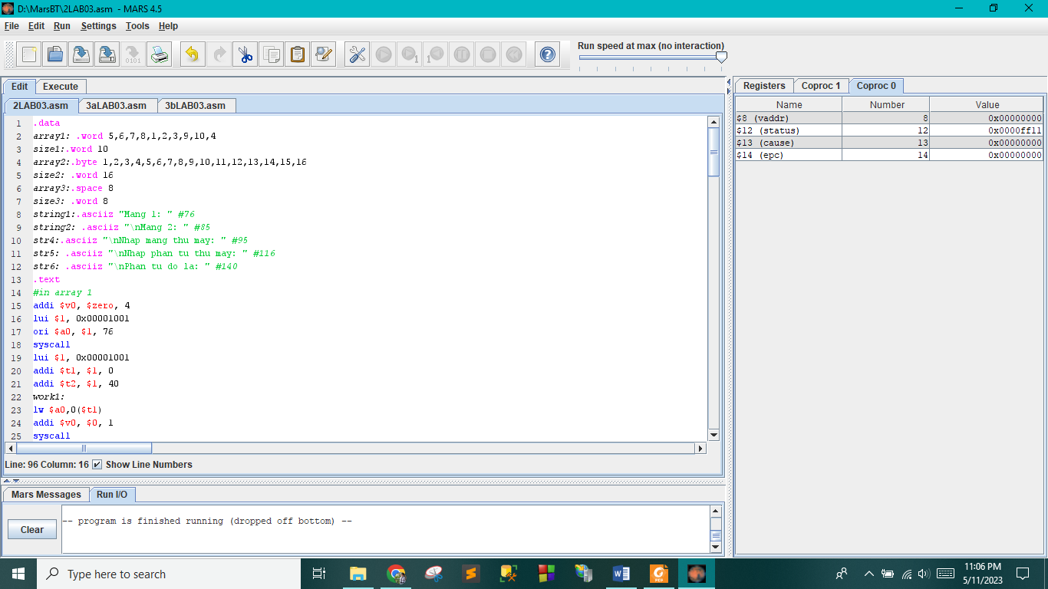

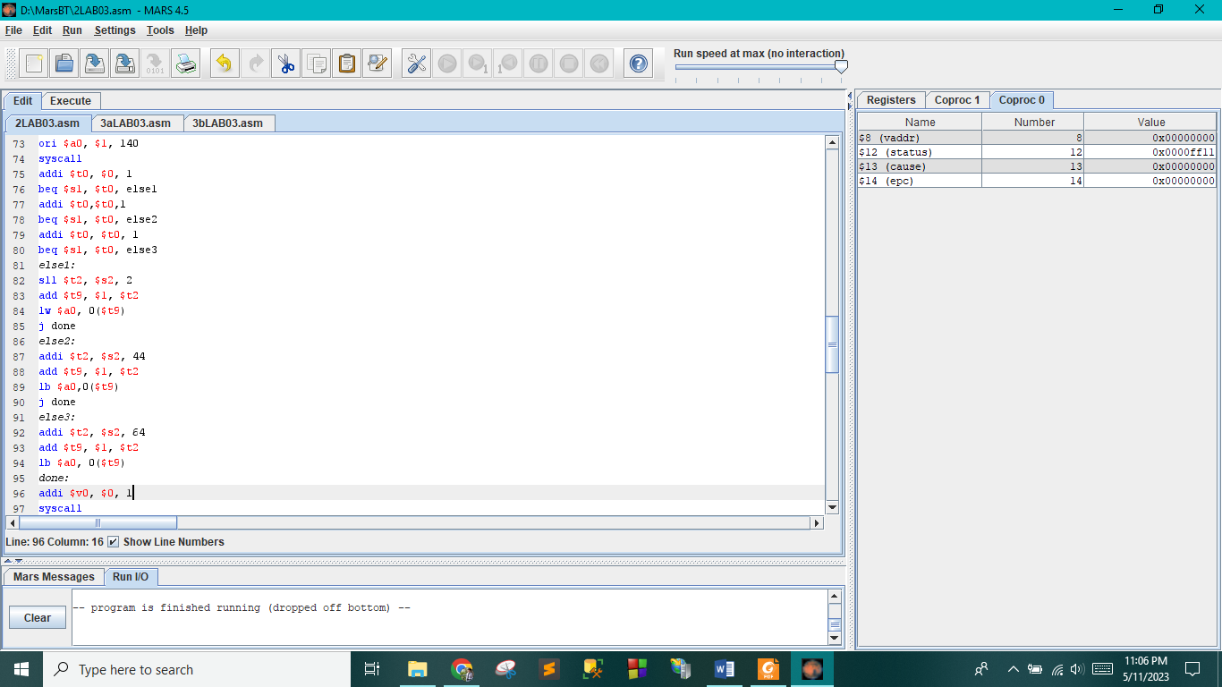

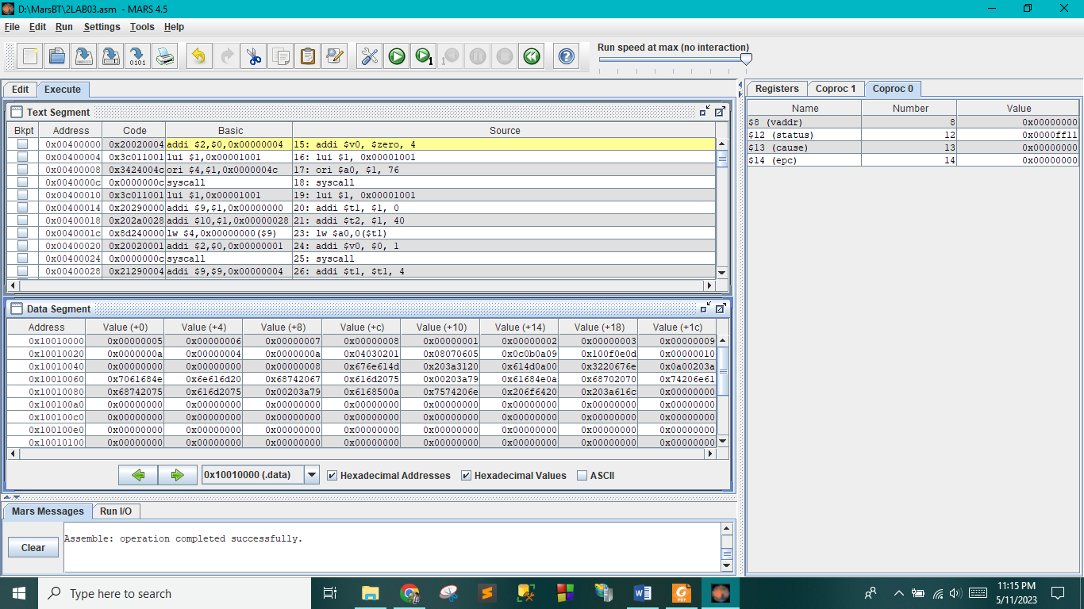

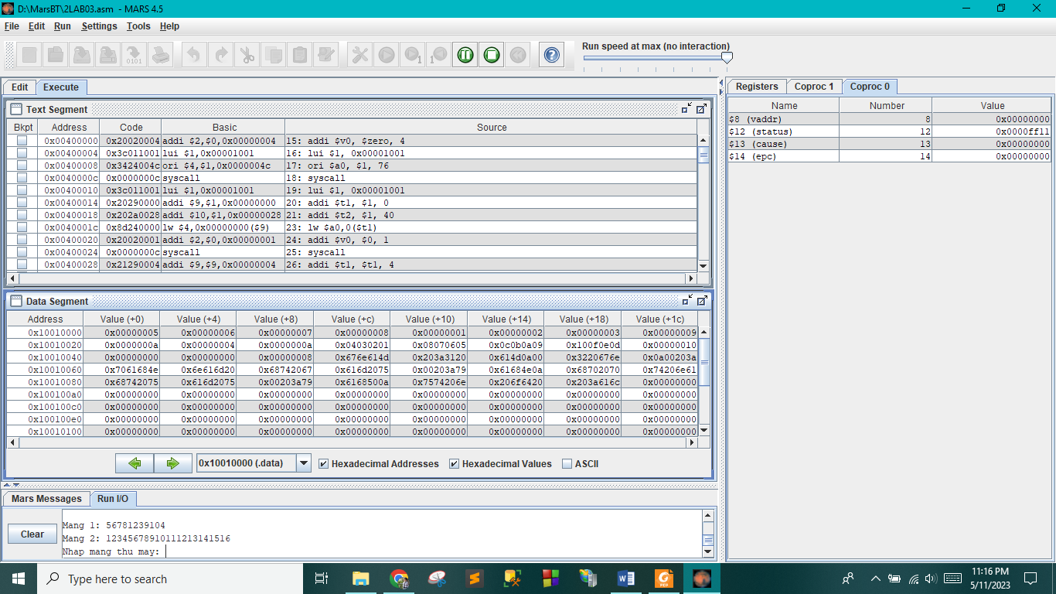

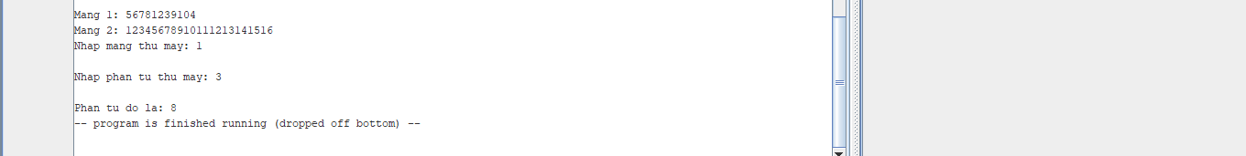

3.

a)

.data

endl :.asciiz "\n"

max :.asciiz "Max = "

min :.asciiz "Min = "

mangso :.word 100

solonnhat:.asciiz "So lon nhat = "

somin:.asciiz "So nho nhat = "

tongphantu:.asciiz "Tong cac phan tu = "

.text

li $v0,5

syscall

move $s1,$v0

la $t0,mangso

addi $t1,$0,0

nhap:

beq $t1,$s1,exit

li $v0,5

syscall

sll $t2,$t1,2

add $t2,$t2,$t0

sw $v0,0($t2)

add $s4,$s4,$v0

addi $t1,$t1,1

j nhap

exit:

lw $s5,0($t0)

lw $s6,0($t0)

addi $t3,$0,0

tinhmin:

beq $t3,$s1,exit2

sll $t6,$t3,2

add $t6,$t6,$t0

lw $t7,0($t6)

addi $t3,$t3,1

slt $t8,$t7,$s5

beq $t8,0, tinhmax

move $s5,$t7

j tinhmin

tinhmax:

sgt $t9,$t7,$s6

beq $t9,0,tinhmin

move $s6,$t7

j tinhmin

exit2:

li $v0,4

la $a0,somin

syscall

li $v0,1

addi $a0,$s5,0

syscall

li $v0,4

la $a0,endl

syscall

li $v0,4

la $a0,solonnhat

syscall

li $v0,1

addi $a0,$s6,0

syscall

li $v0,4

la $a0,endl

syscall

li $v0,4

la $a0,tongphantu

syscall

li $v0,1

addi $a0,$s4,0

syscall

li $v0,4

la $a0,endl

syscall

li $v0,5

syscall

move $s7,$v0

sll $k0,$s7,2

add $k0,$k0,$t0

lw $t7,0($k0)

li $v0,1

addi $a0,$t7,0

syscall

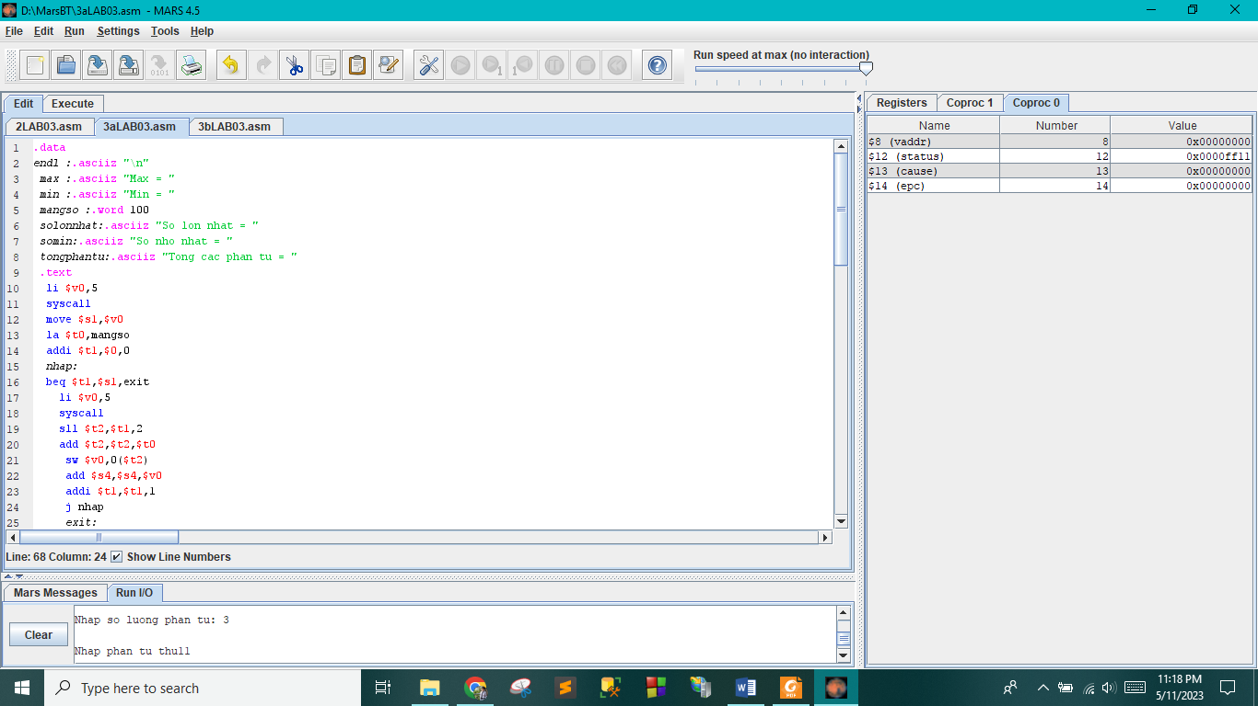

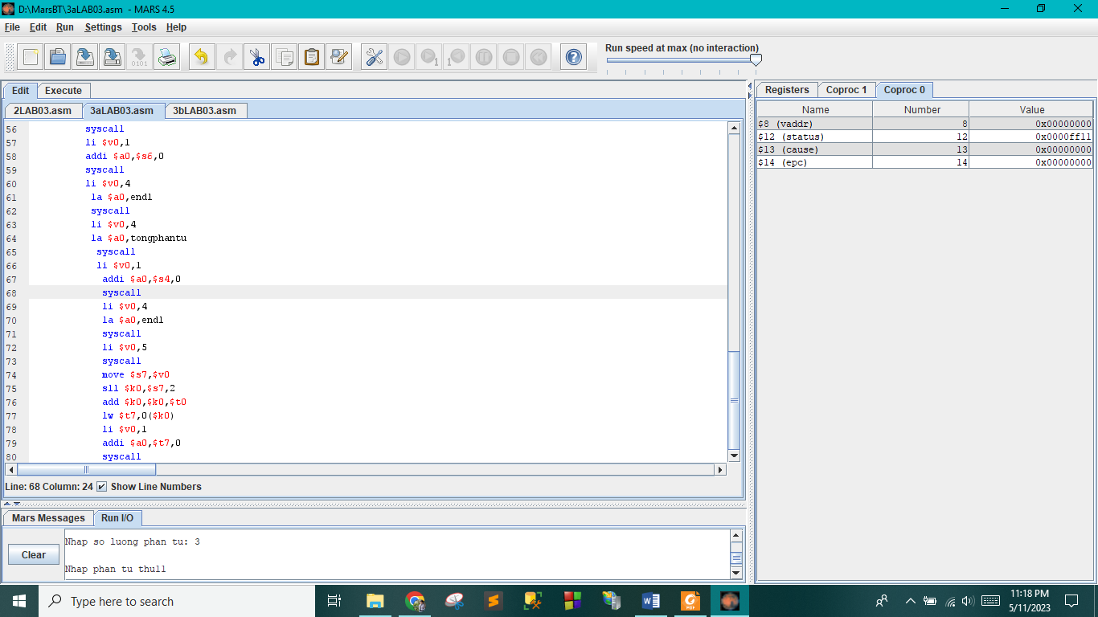

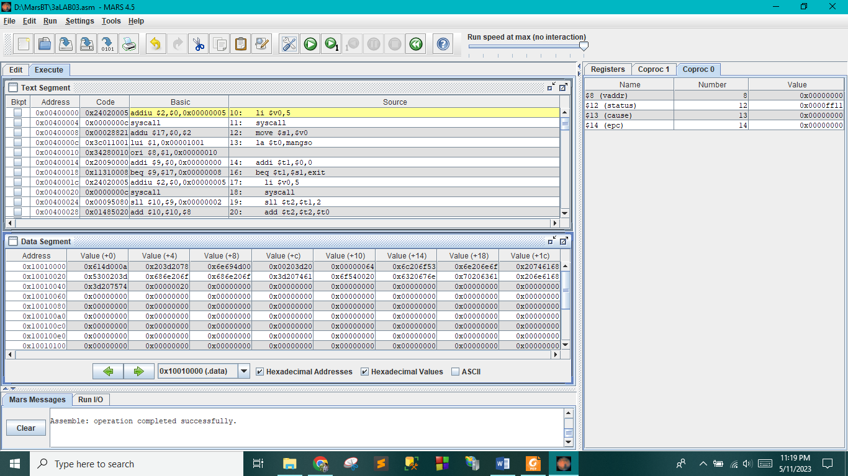

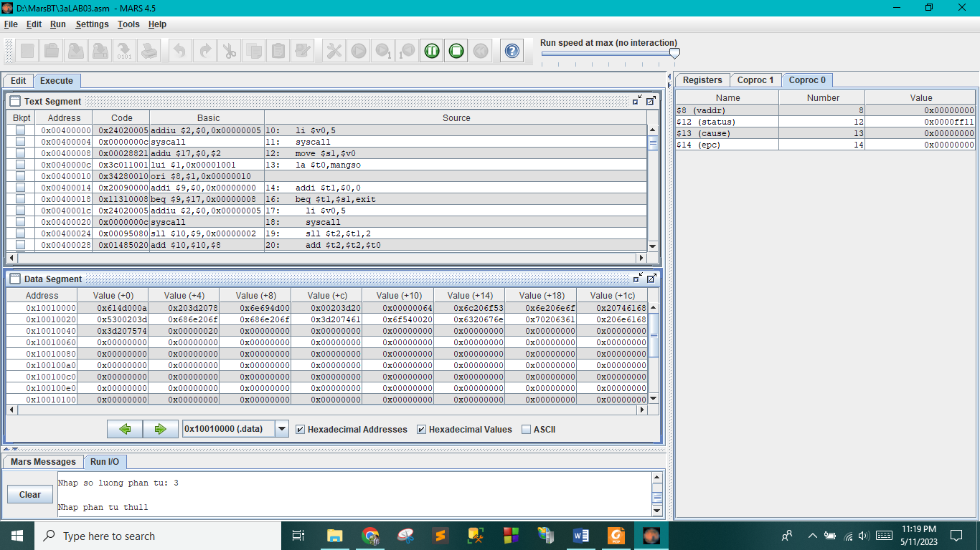

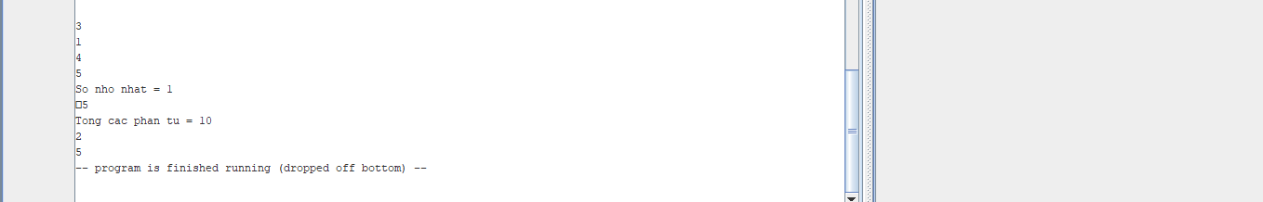

b)

.data

strl: .asciiz "Nhap so luong phan tu: "#24

str2: .asciiz "\nNhap phan tu thu"#19

str3: .asciiz":"#3

str4: .asciiz "\nNhap i: "#10

str5: .asciiz "\nNhap j: "#10

array: .word

.text

lui $1,0x00001001

addi $s3, $1,0

addi $a0,$1,0

addi $v0,$0,4#xuat strl

syscall

addi $v0, $0, 5

syscall

addi $s1, $v0, 0

addi $t9, $1,0

sll $t8, $s1, 2

add $t8, $t9, $t8

IN:

addi $a0,$1,24

addi $v0,$0,4#xuat str2

syscall

addi $t1, $t1, 1# xuất stt

addi $a0, $t1, 0

addi $v0, $0, 1

syscall

addi $a0,$1,43

addi $v0,$0,4#xuat str3

syscall

addi $v0, $0, 5

syscall

sw $v0, 0($t9)

addi $t9, $t9, 4

bne $t9, $t8, IN

addi $a0,$1,46

addi $v0,$0,4#xuat str4

syscall

addi $v0, $0, 5

syscall

addi $s0, $v0, 0

addi $a0,$1,56

addi $v0,$0,4#xuat str5

syscall

addi $v0, $0, 5

syscall

addi $s1, $v0, 0

sll $t1, $s0, 2

add $s3, $s3, $t1

slt $t0, $s0, $s1

beq $t0, $0, J

sw $s0, 0($s3)

j EXIT

J:

sw $s1, 0($s3)

EXIT:

